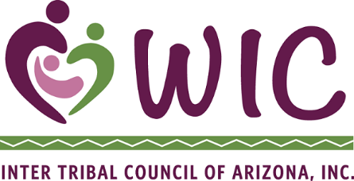
Inter Tribal Council of Arizona

WIC Program

Training Agreement Form

The cost of the training is considered by ITCA to be an investment on your behalf to benefit you and the ITCA WIC program and training is a requirement of the Memorandum of Agreement between ITCA and your agency. ITCA will provide full payment to the entity providing the training with the understanding that you agree to attend and successfully complete the training.

I ___________________________________________________ am committed to attending and successfully passing the following scheduled training on the dates listed below. I have arranged my schedule in order to attend the training and complete assignments.

Please register me for the following trainings:

Title: Dates:
_________________________________________________________________________________________________________________________________
_________________________________________________________________________________

Attached are the necessary registration forms.

I understand that ITCA will not fund registration or books for DEP or other college courses from either the ITCA or local agency budget if I receive a grade of “D”, “F” or “W” (withdrawal) or any grade that reflects unsuccessful completion in any two classes. I will still be required to successfully complete the courses, but the funding for the classes must be provided by non-WIC funds.

Staff Signature: ________________________________________ Date: _____________

WIC Manager Signature: _________________________________ Date: _____________

