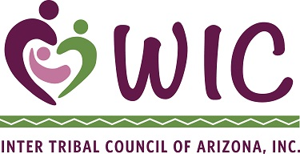

Inter Tribal Council of Arizona, Inc.

WIC Program

Training Agreement Form

The cost of the training is considered by ITCA to be an investment on your behalf to benefit you and the ITCA WIC program and training is a requirement of the Memorandum of Agreement between ITCA and your agency. ITCA will provide full payment to the entity providing the training with the understanding that you agree to attend and successfully complete the training.

I ___________________________________________________ am committed to attending and successfully passing the following scheduled training on the dates listed below. I have arranged my schedule in order to attend the training and complete assignments.

Please register me for the following trainings:

Title: Dates:
_________________________________________________________________________________________________________________________________
_________________________________________________________________________________

Attached are the necessary registration forms.

I understand that if I do not attend the training or successfully pass the training I must repay ITCA the full amount of the registration fee, travel, per diem and lodging costs.

Staff Signature: ________________________________________ Date: _____________

WIC Director Signature: _________________________________ Date: _____________

